Batch: B2 Roll No.: 16010121200

Experiment No. 9

Grade: AA / AB / BB / BC / CC / CD /DD

Signature of the Staff In-charge with date

Title: Case study on any one Special Neural Network
________________________________________________________________________________
Aim: To understand the special neural network and their applications (Boltzmann Machine)
________________________________________________________________________________
Expected Outcome of Experiment:
CO3: Understand perceptron’s and counter propagation networks. _________________________________________________________________________________
Books/ Journals/ Websites referred:
- https://www.tutorialspoint.com/artificial_neural_network/artificial_neural_network_boltzmann_machine.htm#:~:text=Training%20Algorithm&text=Boltzmann%20machine%20has%20a%20set,i.e.%20wij%20%3D%20wji.
- https://iq.opengenus.org/boltzmann-machines/
- https://www.codingninjas.com/studio/library/boltzmann-machine---introduction
________________________________________________________________________________
Discuss the algorithm and application of following special networks

- Boltzmann machine
Objective:
The main purpose of Boltzmann Machine is to optimize the solution of a problem by optimizing the weights and quantity related to that particular problem.

Architecture:
Two-dimensional array of units.
Weights on interconnections between units are -p where p > 0.
Weights of self-connections are b where b > 0.
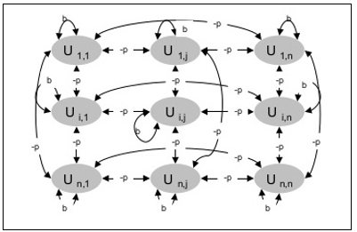

Theory:
Boltzmann Machine is characterized by a network of binary-valued neurons or units that are interconnected. They are often employed in unsupervised learning tasks and probabilistic modeling. The key concept underlying a Boltzmann Machine is the idea of energy. Each configuration of the binary units is associated with an energy, and the network aims to learn the connections (weights) between the units that minimize this energy.
Boltzmann Machines can be categorized into two main types: the symmetrically connected or fully visible Boltzmann Machine (FVBM) and the restricted Boltzmann Machine (RBM). The FVBM has symmetric connections between all the units, making it a more challenging model to train due to the high number of connections. RBMs, on the other hand, are simpler and have a bipartite structure, with visible and hidden units, which makes training more tractable.
The learning process in Boltzmann Machines is typically performed using a Markov Chain Monte Carlo (MCMC) technique known as Gibbs Sampling. During training, the network samples from its probability distribution to adjust weights in a way that reduces the energy of the system and aligns it with the data distribution. This process is iterative and can be computationally expensive, especially for fully visible Boltzmann Machines.
Training Algorithm:
Because Boltzmann machines have fixed weights, there will be no training algorithm as the weights in the network do not need to be updated. However, before we can test the network, we must first set the weights and determine the consensus function (CF).

Applications:
- Dimensionality reduction
- Data reconstruction
- Recommendation engines
- Classification
- Regression
- Image restoration
- Object detection
- Signal processing

Summary:
A Boltzmann Machine is a type of neural network used for tasks like pattern recognition and data modeling. It's made up of interconnected units that can be on or off, and it uses a learning algorithm based on minimizing energy to adjust the connections between these units. This network is often used for unsupervised learning, where it figures out patterns in data without needing labeled examples. However, it is a bit complex and computationally intensive.

Date: 1/11/2023 Signature of faculty in-charge

